**BigBasket product analysis report**

* **Prepared by: Divya Sawant**
* **Guide by: Vishal Sir**

***Introduction:***This analysis aims to explore the product offerings of Big-Basket, an grocery store. The dataset contains various details about products, including their product, categories, sub-categories, brands, and prices. By examining this data, we aim to identify key insights such as the most common product categories, popular brands, price distributions. These insights will help in understanding the product landscape of Big-Basket and can be used to inform business decisions, marketing strategies, and inventory management.

***Objective:***

* Top 5 Category
* Top 3 sub-category
* Top 5 Brand
* Difference b/w agv. sale price & market price
* Product distribution across category
* Product distribution across price category
* Rating Brand (Low, mid ,high)
* Top 2 brand in top category
* Recommendation system

***Data overview:***

* ***Data source:***

The dataset is sourced from Big-Basket product ecommerce platform and it is publicly available on Kaggle platform.

***Data description:***

The analysis focused on following columns: Product(23,540) , category(11),sub-category(90),sale price, market price, brand(2313), rating(1 to 5) and types of product.

* **Records:** [number of rows=27,555]
* **Features:** [numbers of columns=9]

***Methodology:***

The analysis was conducted using Python and key libraries such as Pandas for data manipulation, Seaborn and Matplotlib for data visualization, and Microsoft Word for report preparation. Statistical methods including mean, median, mode, and the five-number summary were applied to summarize data and identify key patterns and trends.

***Numerical findings & analysis using Visualisation:***

* **Top 5 Category**

***Key findings:***

* **Beauty & Hygiene:**

Percentage: 36.4%

This is the largest category, indicating a significant focus on beauty and hygiene products within BigBasket’s offerings.

* **Gourmet & World Food**:

Percentage: 21.7%

This category is the second largest, showing that there is a high demand or a broad range of gourmet and international food items.

* **Kitchen, Garden & Pets**:

Percentage: 16.6%

Products related to kitchen, garden, and pets make up a substantial portion of the inventory, indicating a diverse product range catering to household needs.

* **Snacks & Branded Foods**:

Percentage: 13.0%

Snacks and branded foods are a significant category, reflecting consumer interest in ready-to-eat and branded food products.

* **Foodgrains, Oil & Masala**:

Percentage: 12.4%

This category represents essential grocery items, which are fundamental to everyday cooking and meal preparation.

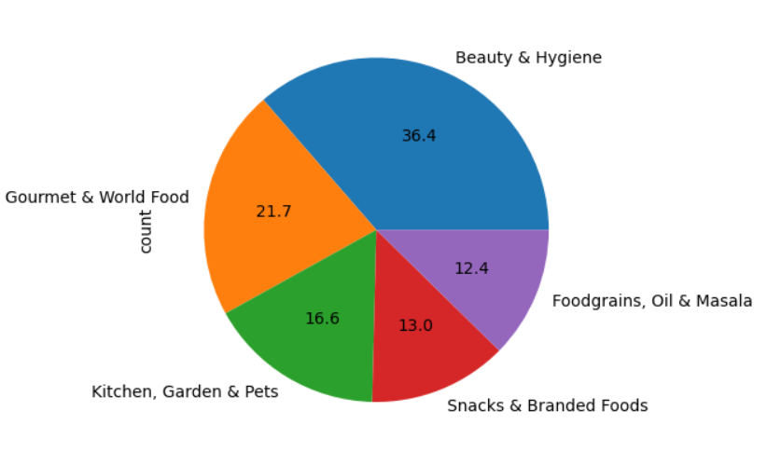

* ***Top 3 sub-category***

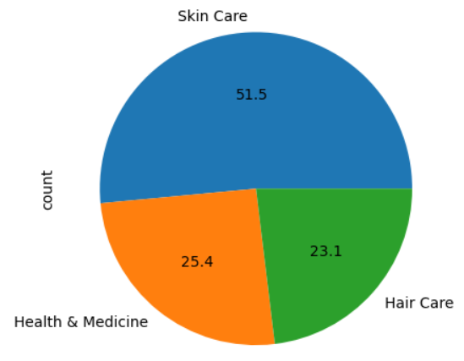

**Key findings:**

* **Skin Care:**

Percentage: 51.5%

Skin care products make up more than half of the Beauty & Hygiene category. This indicates a strong emphasis and consumer demand for skincare items.

* **Hair Care**:

Percentage: 23.1%

Hair care products form nearly a quarter of the category, showing significant interest and variety in hair care solutions.

* **Health & Medicine**:

Percentage: 25.4%

Health & medicine products also hold a substantial portion within the Beauty & Hygiene category, highlighting the importance of health-related items alongside personal care.

* **Top 5 brand**

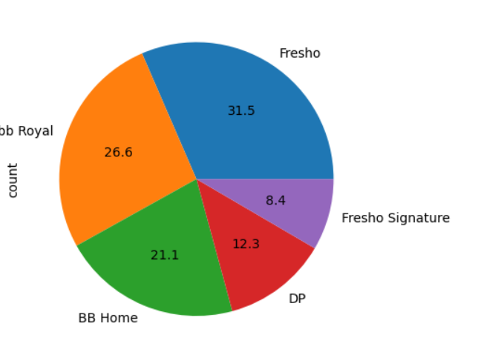

***Key findings:***

* **Fresho:**

Percentage: 31.5%

Fresho is the leading brand, representing nearly a third of the product offerings. This indicates a strong presence and consumer preference for Fresho products.

* **bb Royal:**

Percentage: 26.6%

bb Royal follows closely behind, making up over a quarter of the products. This suggests a significant market share and popularity among consumers.

* **BB Home:**

Percentage: 21.1%

BB Home also holds a substantial portion, indicating a wide range of home-related products that are popular among customers.

* **DP:**

Percentage: 12.3%

DP products account for a notable portion, showcasing their relevance and demand in the market.

* **Fresho Signature**:

Percentage: 8.4%

Fresho Signature, while the smallest among the top 5, still holds a significant share, reflecting its specialized product offerings and consumer interest.

* **Difference b/w agv. sale price & market price**

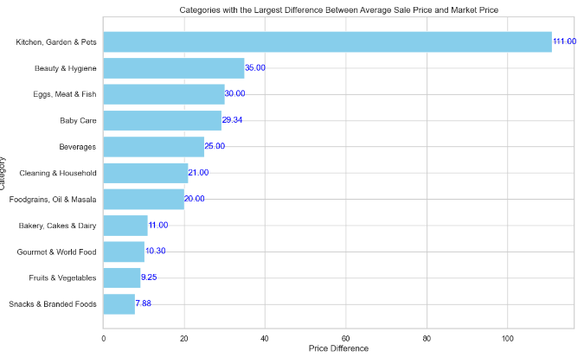

***Key findings:***

**Top Price Difference in "Kitchen, Garden & Pets"**

This category has the largest price difference, with an average of ₹111 between sale price and market price.

**"Beauty & Hygiene" Category** (₹35)

A relatively large difference exists between the sale price and the market price.

**Small Differences** (₹10–₹20)

“Bakery, Cakes & Dairy," "Fruits & Vegetables," "Snacks & Branded Foods," etc

* **Product distribution across category**

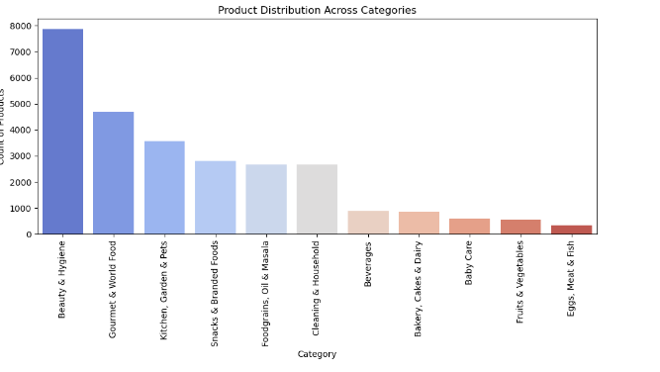

***Key findings:***

"Beauty & Hygiene"

This category has the largest number of products (around 8,000), significantly more than any other category.

"Gourmet & World Food" and "Kitchen, Garden & Pets"

These two categories follow "Beauty & Hygiene" with substantial product counts (approximately 4,000 and 3,000 products respectively).

Lower Product Count Categories

"Beverages," "Bakery, Cakes & Dairy," "Baby Care," "Fruits & Vegetables," and "Eggs, Meat & Fish" have relatively fewer products in comparison.

* **Product distribution across price category**

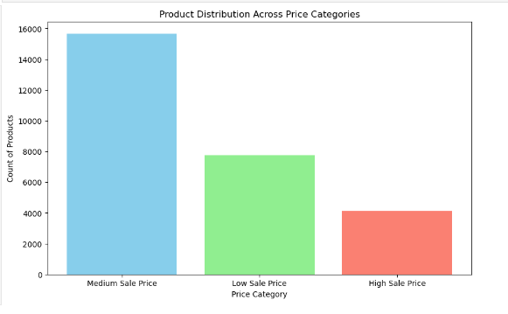

***Key findings:***

**Medium Sale Price:**

* This category has the highest number of products.
* Approximately 15,500 products fall into this category.

**Low Sale Price:**

* This category has a moderate number of products.
* Around 9,000 products are in this category.

**High Sale Price:**

* This category has the least number of products.
* Roughly 5,000 products belong to this category.
* **Rating Brand (Low, mid ,high)**

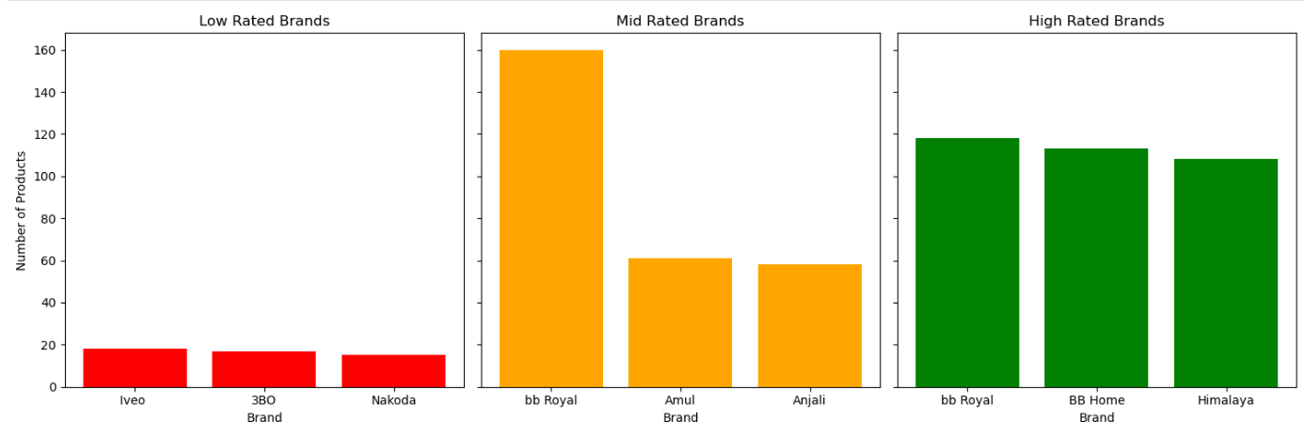

***Key findings:***

**Low Rated Brands:**

* 3BO: Has the least number of products, with fewer than 100.
* Iveo: Around 150 products.
* Nakoda: Slightly fewer than Iveo, around 130 products.

**Mid Rated Brands:**

* Amul: Approximately 200 products.
* Anjali: The lowest in this category, around 100 products.
* bb Royal: Significantly higher, with around 500 products.

**High Rated Brands:**

* BB Home: Around 400 products.
* Himalaya: The least in this category, around 200 products.
* bb Royal: Highest, around 500 products.
* **Top 2 brand in top category**

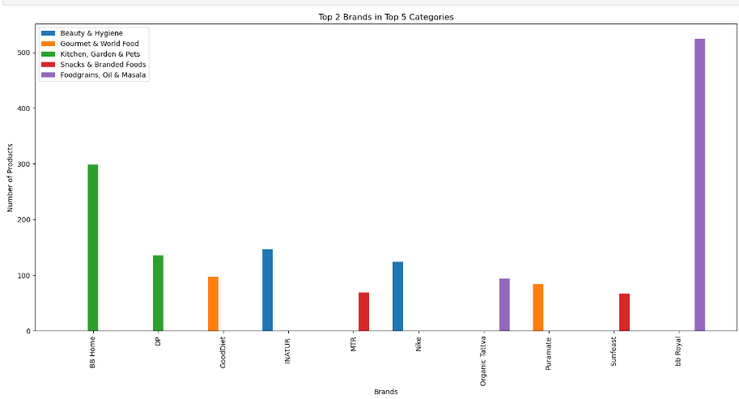

***Key findings:***

* **Beauty & Hygiene:**

INATUR: Approximately 150 products.

Nike: Also around 150 products.

* **Gourmet & World Food:**

GoodDiet: Around 100 products.

Puranate: Around 100 products.

* **Kitchen, Garden & Pets:**

BB Home: Around 350 products.

DP: Approximately 150 products.

* **Snacks & Branded Foods:**

MTR: Around 100 products.

Sunfeast: Also around 100 products.

* **Foodgrains, Oil & Masala:**

bb Royal: Significantly higher with around 500 products.

Organic Tattva: Approximately 150 products.

* **Recommendation system**

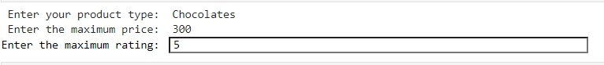

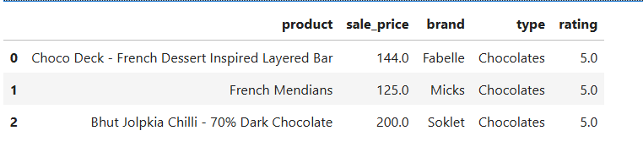

***Key findings:***

The function allows users to filter products based on specific criteria they provide: product type, maximum price, and maximum rating.

Only products that meet the specified maximum price and rating are considered. This helps users find products within their budget and quality expectations.

**Conclusion:**

The dataset reveals a clear distribution of product prices across different categories. The majority of products fall within the medium price range (100-500 rupees), followed by a significant number of low-priced products (below 100 rupees), and a smaller proportion of high priced products (above 500 rupees). This indicates that the product assortment heavily leans towards affordable and mid-range products.

***Recommendation:***

* **Product Improvement:**

Work with low-rated brands to enhance product quality based on customer feedback. This might involve improving materials, design, functionality, etc.

Perform regular quality checks to ensure consistent product standards.

* **Identify Common Issues:**

Analyze customer feedback for low-rated brands to identify common issues. This could include product quality, customer service, delivery issues, etc.

Address these issues promptly and effectively to improve customer satisfaction.

* **Medium Sale Price Products:**

Since the medium sale price category has the highest number of products, focus marketing efforts on these products. Highlight their value for money to attract more customers.

* **Top Brands in Key Categories:**

Promote brands like bb Royal in the Foodgrains, Oil & Masala category, and BB Home in the Kitchen, Garden & Pets category. Their high product count suggests strong market presence and customer trust.